**Lab 1: INTRODUCTION TO DSP TOOLS**

**Objectives:**

* To learn about the basic tools used in DSP
* To understand the working of various waves

**Theory:**

MATLAB

The name MATLAB stands for matrix laboratory. MATLAB was written originally to provide easy access to matrix software developed by LINPACK and EISPACK projects. MATLAB is a high performance language used for technical computing. It integrates computation, visualization, and programming in an easy to use environment were problems and solutions are expressed in familiar mathematical notations. MATLAB is basically used in data analysis and processing, visualization, exploration.

Many engineers and scientists, use MATLAB for wide range of applications in industry and academia, including deep learning and machine learning.

Some basics of MATLAB are:

* Contents
* Vectors
* Plotting
* Functions
* Polynomials as vectors
* Matrices

**Waves**

**Sine wave:** Sine wave A sine wave is a geometric waveform that oscillates (moves up, down or side-to-side) periodically, and is defined by the function y = sin x. In other words, it is an s-shaped, smooth wave that oscillates above and below zero.



**Cosine wave:** Cosine wave A cosine wave is a signal waveform with a shape identical to that of a sine wave , except each point on the cosine wave occurs exactly 1/4 cycle earlier than the corresponding point on the sine wave.



In octave online,

1. X=4

Y=5

X+Y=9

2. X*Y=20

3. X/Y=

4. Y/X=

5. Pi=3.1415

Format long

Pi=3.141523456575

Format short

Pi=3.1415

6. Clc

7.clear all

8.z=1-1i

Real z=122

Real(z)=1

Imag(z)=-1

Conj(z)=1+1i

Abs(z)=1.414

Angle(z)=-0.7854

9. sin(45)=0.707

10.rad2deg(ans)=-45

11.x=[1,2,3,4]

X=1 2 3 4

X=[1;2;3;4]

X=1

2

3

4

12. X=[1,2]

Y=[3,4]

X +Y=[4,6]

13.X –Y=[-2 ,-2]

x.*y=[3,8]

14.transpose(x)=1

2

15.clc

16.clear all

X=undefined

17.x=4;

18.y=5;

x+y=9

19.x/y=0.8000

20.Floor(2.1456)=2

21.ceil(2.1486)=3

22.round(2.1486)=2

23.round(2.6664)=3

**Q1.**

Clc

Close all

A=5;

f=4;

t=0:0.001,1;

X=A*cos(2*pi*f*t);

Plot(t,x);

Grid on;

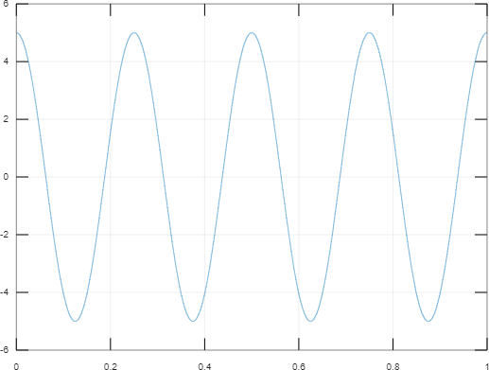

**Q2.**

Clc

Close all

A=5;

f=4;

t=0:0.01,1;

X=A*cos(2*pi*f*t);

stem(t,x);

Grid on;

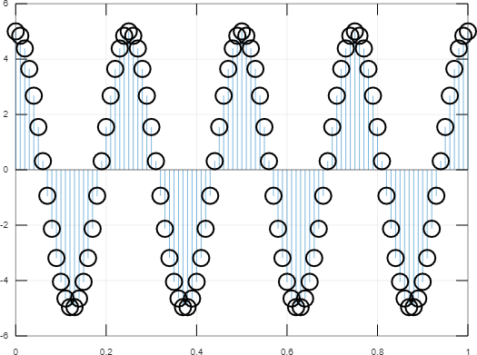

**Q3.**

Clc

Close all

A=5;

f=4;

t=0:0.001,1;

X=A*sin(2*pi*f*t);

plot(t,x);

Grid on;

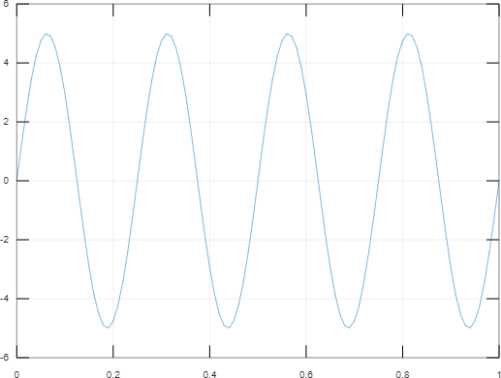

**Q4.**

Clc

Close all

A=5;

f=4;

t=0:0.01,1;

X=A*sin(2*pi*f*t);

stem(t,x);

Grid on;

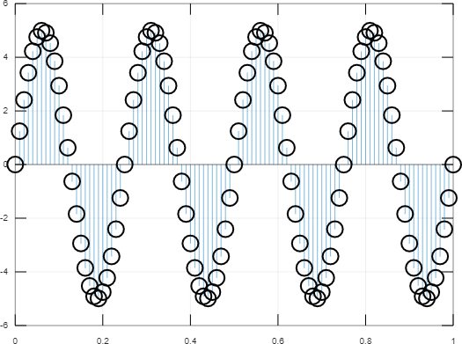

**DISCUSSION AND CONCLUSION**

In this lab, we learnt about the basic tools of DSP and also learnt how to implement them in various functions. Also we studied about some basic MATLAB operations and performed some tasks using those functionalities. Moreover we plotted some diagram and analyzed their behavior.